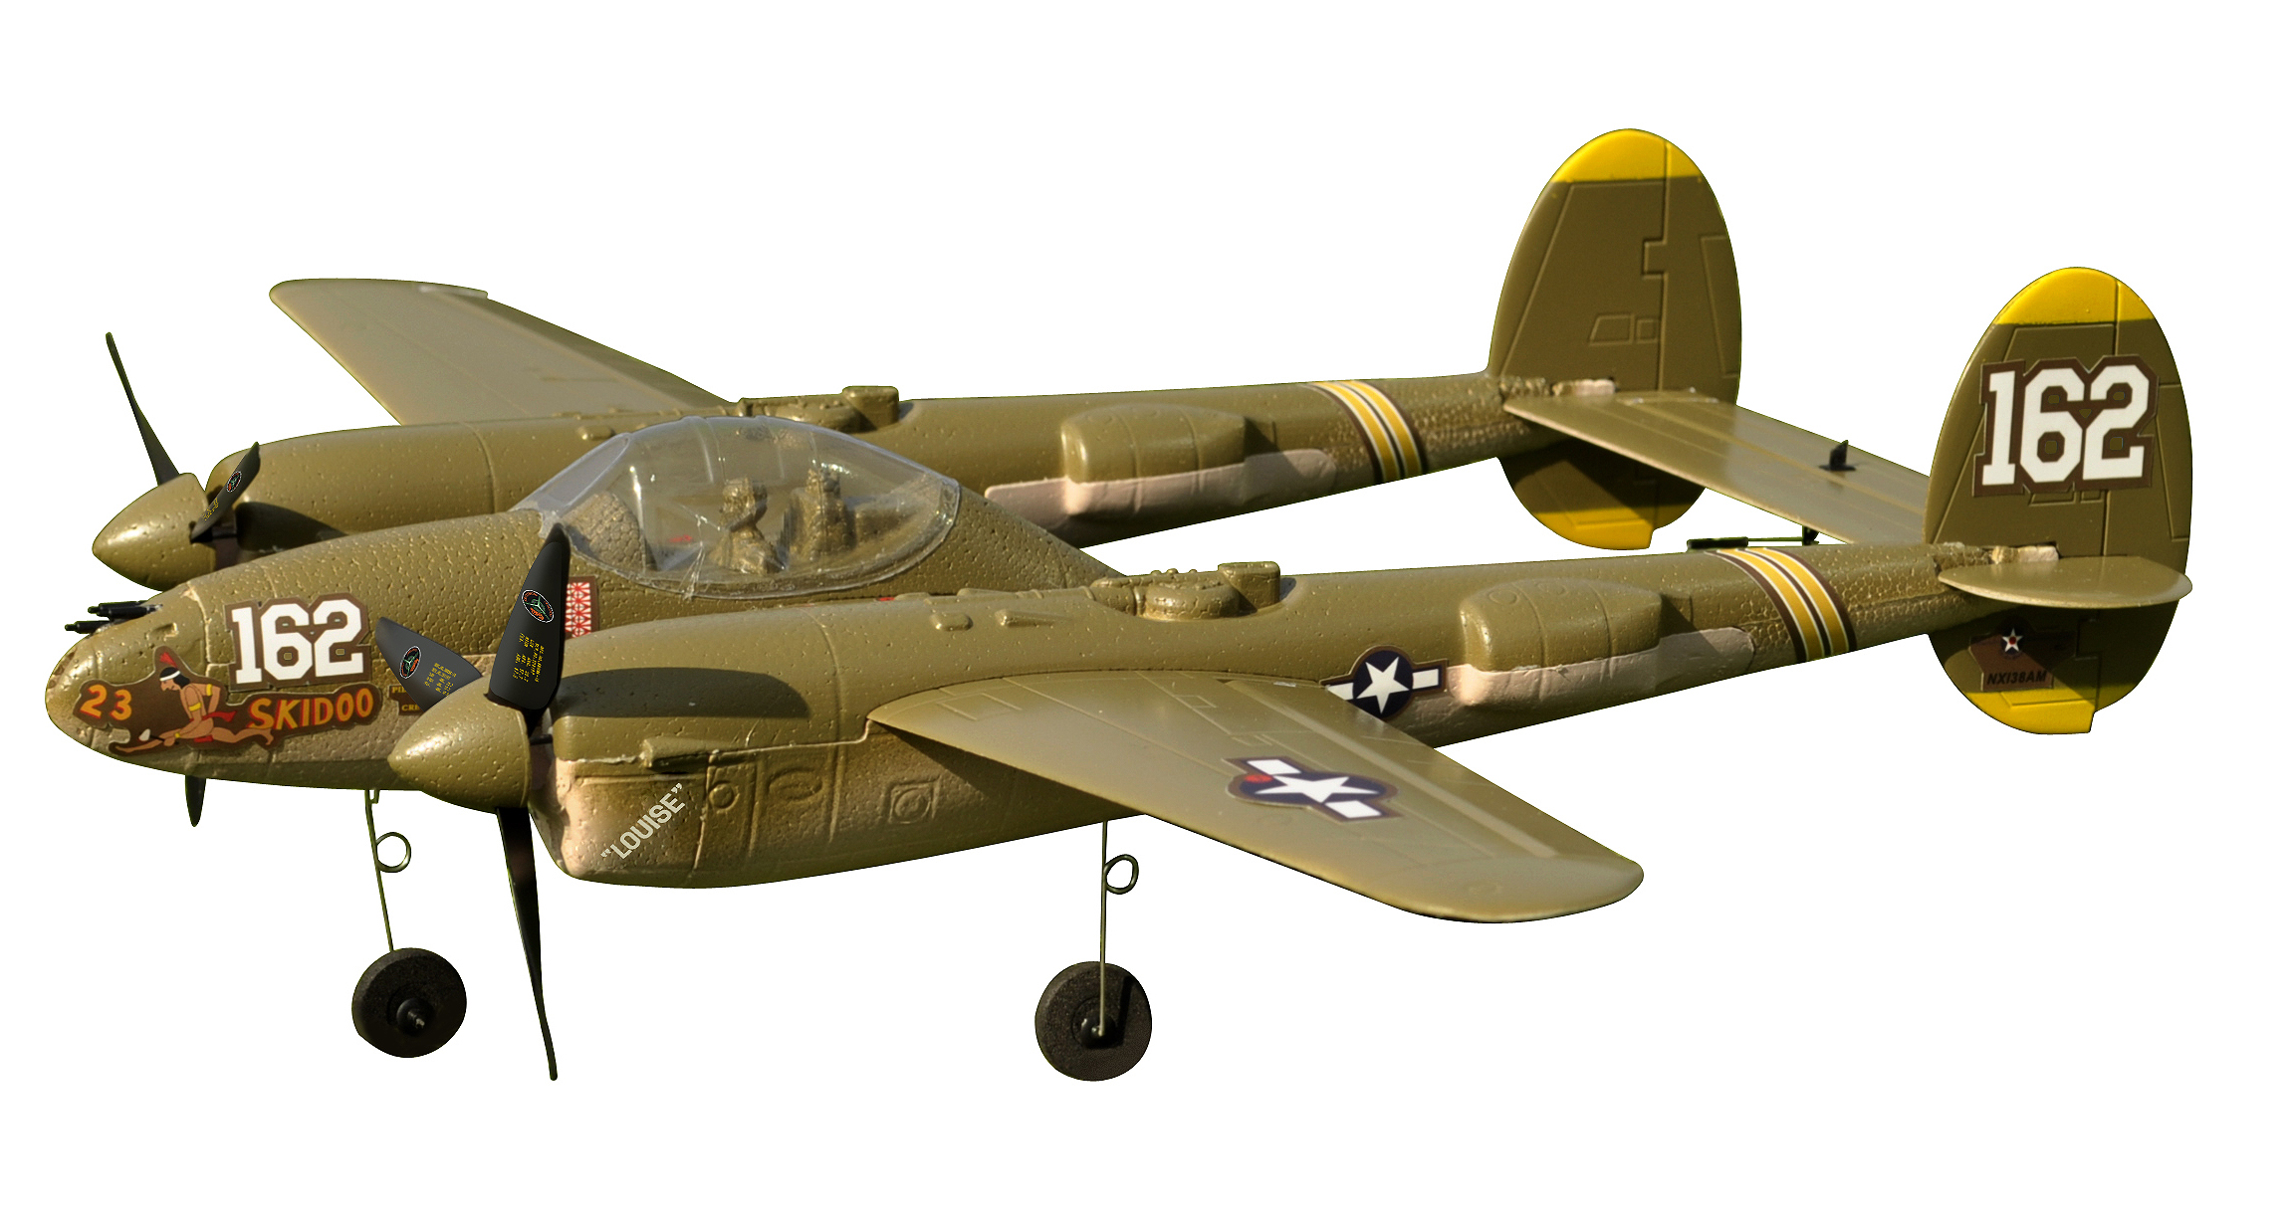

P-38 Lightning

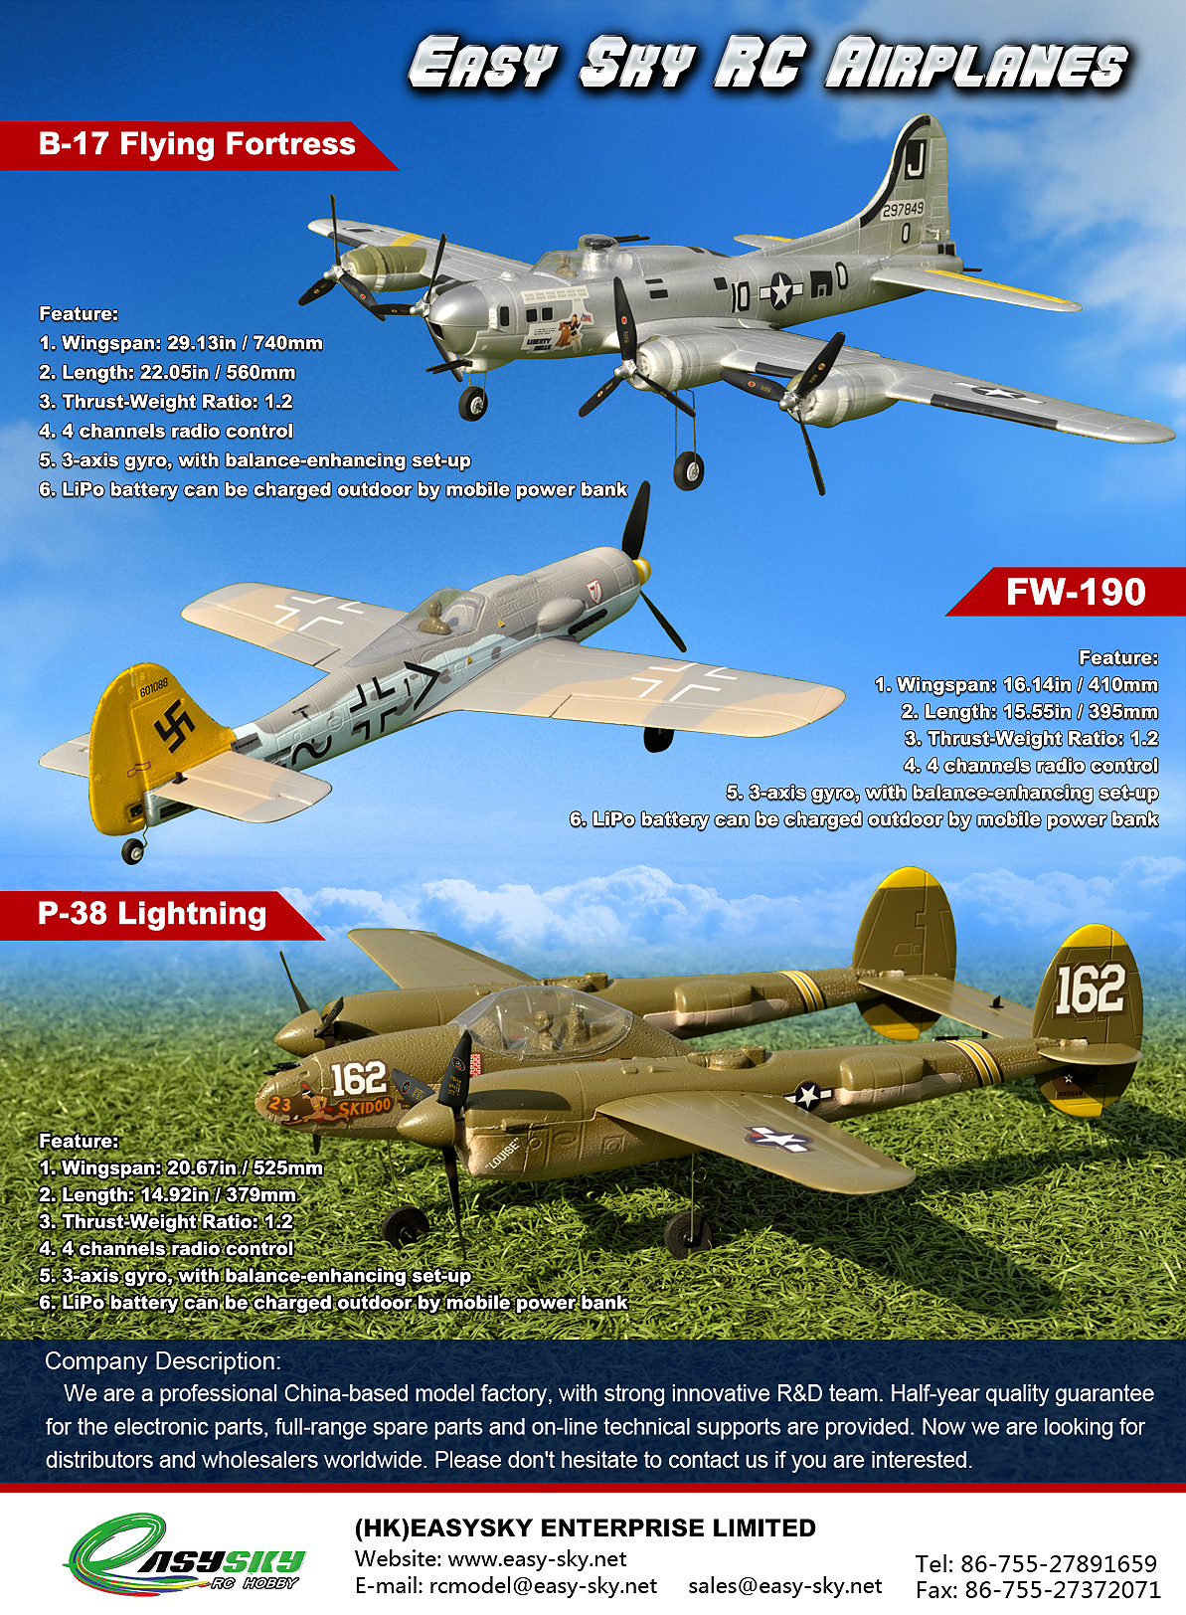

INCLUDED ITEMS

● Assembled Micro P-38
● LiPo battery
● Transmitter
● Charging box
● Charging cable

ITEMS TO BE COMPLETED

● 4*AA batteries

PRECAUTIONS

Your Micro P-38 should not be considered a toy, but rather a sophisticated, working model that functions very much like a full-size airplane. Because of its performance capabilities, the Micro P-38, if not assembled and operated correctly, could possibly cause injury to yourself or spectators and damage to property.

1. Operate the plane according to the instructions. DO NOT alter or modify the model. If you make any modifications, you void your warranty.

2. Test the operation of the model before each flight to ensure that all equipment is operating properly and that the model remains structurally sound.

3. Fly only indoors or outdoors on very calm days (with wind speeds less than 5mph) and in large open areas free of trees, people, buildings, or any other obstacles.

4. Although the Micro P-38 are designed to be fairly easy to fly, if you are a first-time pilot, you may still benefit from the assistance of an experienced pilot for your first flights. If you’re not a member of an R/C club, your local hobby shop has information about clubs in your area whose membership includes experienced pilots.

We hope you enjoy flying your Micro P-38.

TRANSMITTER CAUTIONS
● Do not use rechargeable (NiCd) batteries.
● Do not mix old and new batteries.
● Do not mix alkaline, standard (carbon-zinc) or rechargeable (NiCd) batteries.

BATTERY CHARGING PRECAUTIONS
❏ 1. Always remove the battery from your Micro P-38 before charging.
❏ 2. Do not leave a charging battery unattended!
Unplug the battery if it gets warm, even if the charge LED has not gone out.
❏ 3. Use only the charger that comes with your Micro P-38!
WARNING: Misuse or malfunction may overheat the battery and charger, resulting in personal injury or damage to surroundings.

LITHIUM POLYMER BATTERY RECYCLING
ATTENTION: The product you have purchased is powered by a rechargeable battery. At the end of the battery’s useful life, under various state and local laws, it may be illegal to dispose of this battery into the municipal waste system. Check with your local solid waste officials for details in your area for recycling options or proper disposal.

GLOSSARY

● Ailerons: The flight control on the airplane that controls the ability of the airplane to bank left and right.

● Center of Gravity (C.G.): Point at which the aircraft must balance in order to fly properly.

● Elevator: The flight control that controls pitch attitude. By adding power and pitching up, you can make the model climb or loop.

● Glide Slope: The proper path for an airplane approaching a landing strip.

● Lithium Polymer (LiPo) Battery: Rechargeable battery which is used to power the airplane. LiPo batteries are lighter and smaller than most other types of rechargeable batteries.

● Receiver: The unit in the aircraft that receives the signal from the transmitter to provide the input to the servos.

● Servo: The device on the model that moves the flight controls.

● Transmitter (TX): The hand-held unit that sends the signals to the control unit, or receiver (RX), in the aircraft.

ASSEMBLE THE WINGS AND LANDING GEARS

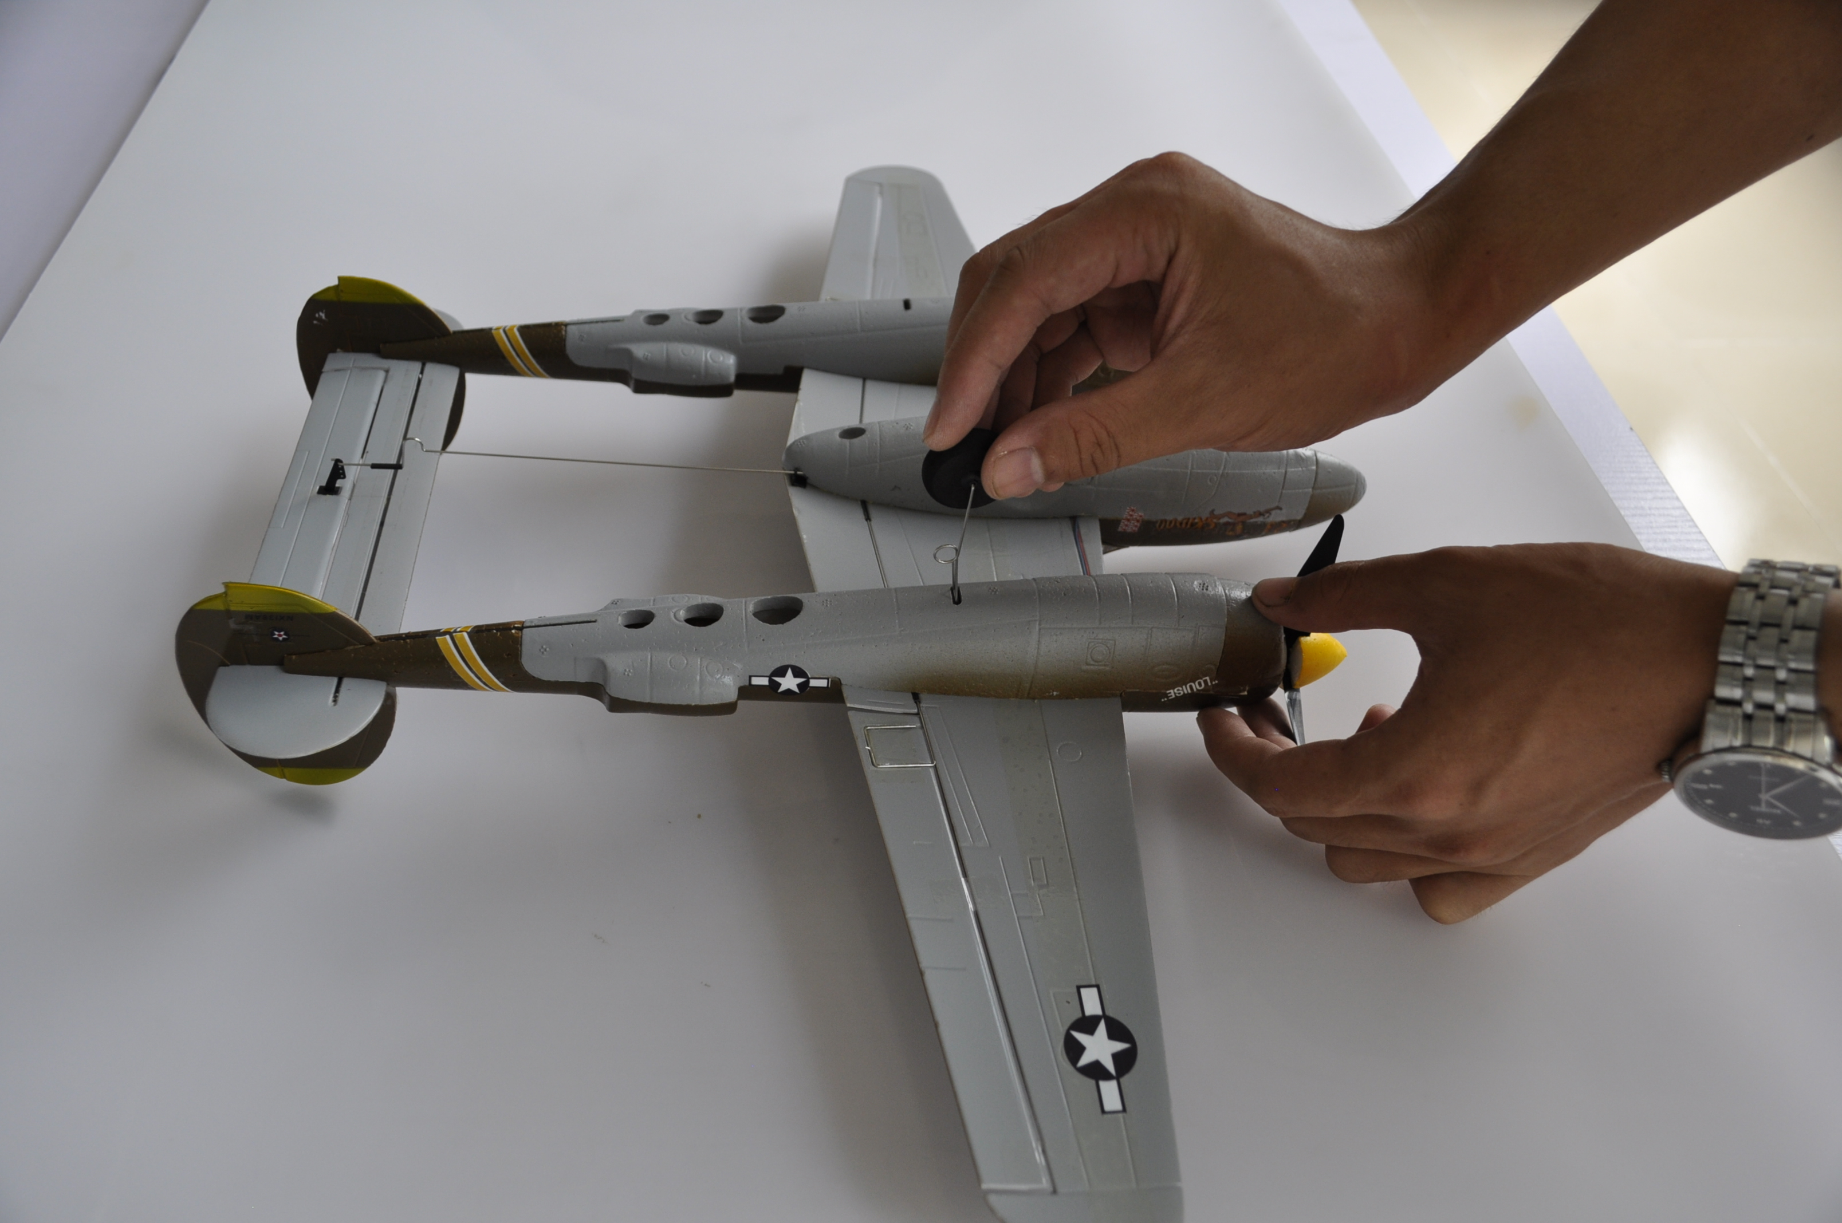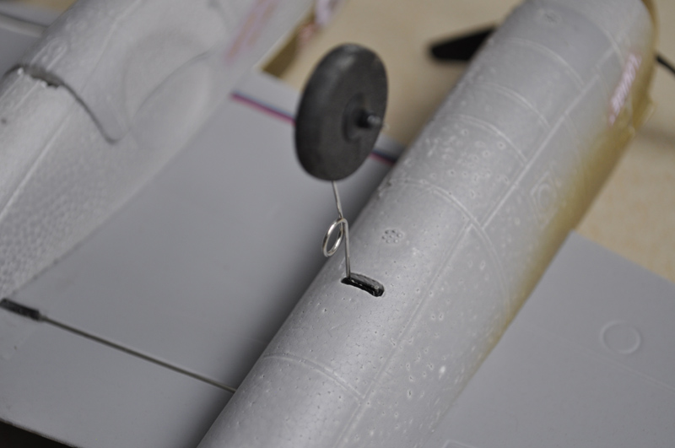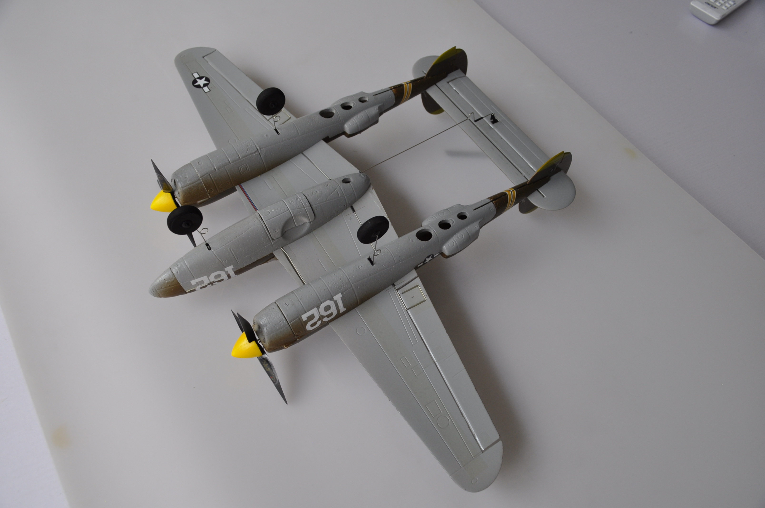

CHARGE THE LIPO BATTERY

Use the charging box included in the package to charge the lipo battery. The power source can be a connected mobile phone adapter, power bank or car charger.

Illuminated green light indicates charging. When the LED goes out, charging is complete.
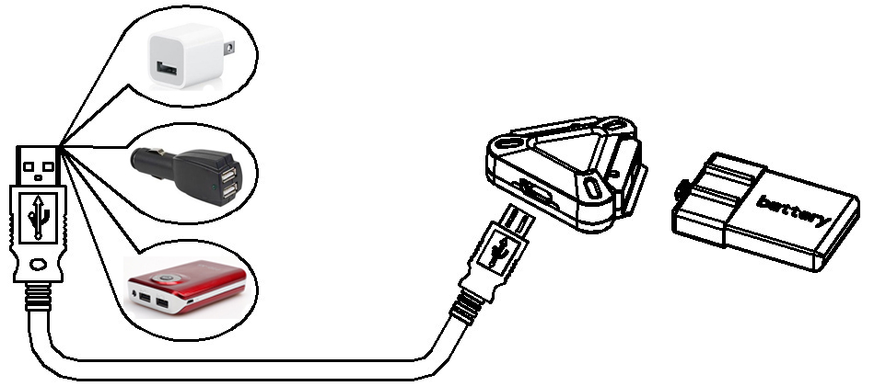

TRANSMITTER FUNCTIONS

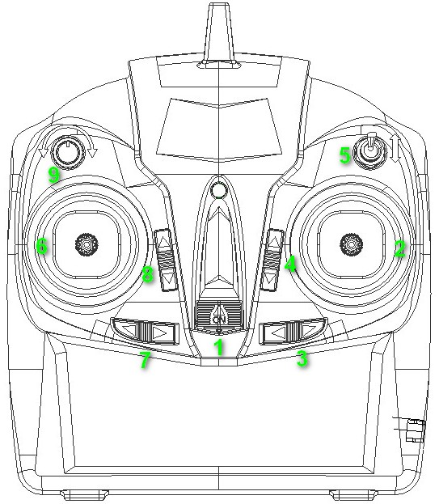
Gyro Sensitivity
High Low
High
D/R
Low
1. Power Switch 2. Elevator / Aileron (mode 2) Throttle / Aileron (mode 1) 3. Aileron Trim 4. Elevator Trim (mode 2) Throttle Trim (mode 1) 5. D/R 6. Throttle / Rudder (mode 2) Elevator / Rudder (mode 1) 7. Rudder Trim 8.Throttle Trim (mode 2) Elevator Trim (mode 1) 9. Gyro PID Tuning Button

LINKING TO MICRO AIRCRAFT

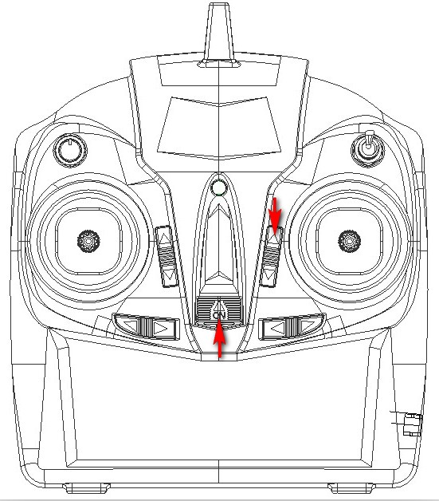
- Power on the receiver.
- Press and hold the upper right trim button, and power on the transmitter.
- Then wait for 3 seconds. When the LED flashes rapidly, release the pressing fingers.
- Linking completes when LED turns solid.

TRANSMITTER SETUP

Enter Setup | 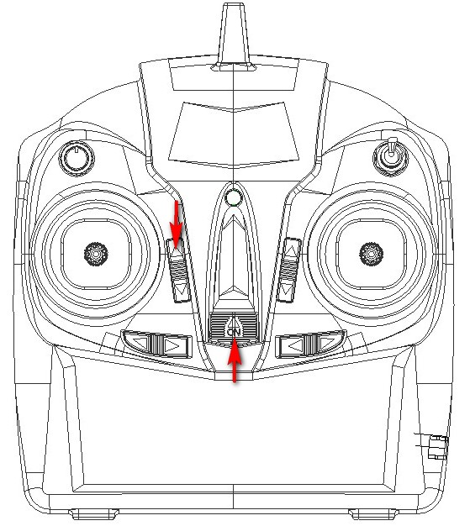 | Press and hold the upper left button, and power on the transmitter. Enter the transmitter setup when “BEEP” is heard.
Control Surface Reverse | MODE 2 :  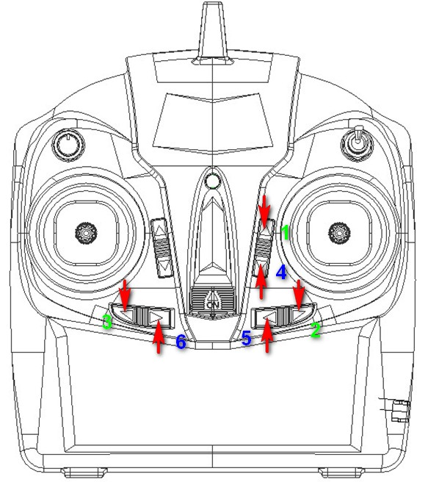  MODE 1:  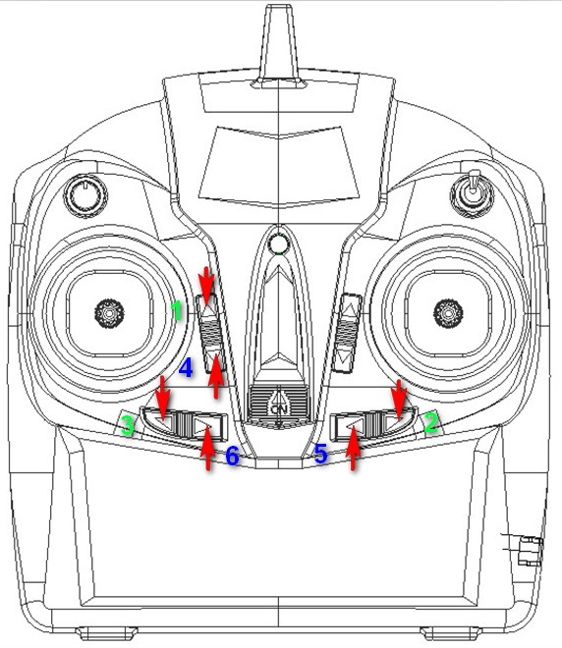 | - Elevator setting: Press and hold button 1 until “BEEP” is heard, then the direction is reversed;  - Aileron setting: Press and hold button 2 until “BEEP” is heard, then the direction is reversed;  - Rudder setting: Press and hold the button 3 until “BEEP” is heard, then the direction is reversed.
Gyro Reverse | MODE 2:  MODE 1: | - Elevator gyro setting: Press and hold on button 4 until “BEEP” is heard, then the direction is reversed;  - Aileron gyro setting: Press and hold on button 5 until “BEEP” is heard, then the direction is reversed;  - Rudder gyroscope: Press and hold on button 6 until “BEEP” is heard, then the direction is reversed.
RESET | 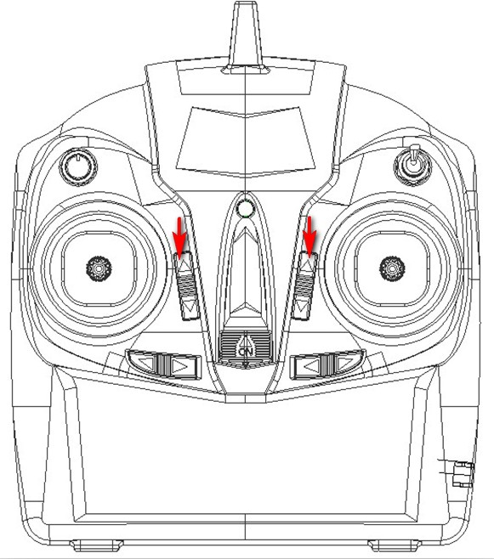 | Power on the transmitter. Press and hold the upper left button and upper right button. All parameters are reset when “BEEP” is heard (Trims return to center; all control surfaces and gyro directions are not reversed).

INSTALLATION AND REMOVAL OF THE LIPO BATTERY

Keep hands clear of the propellers during battery installation and removal.
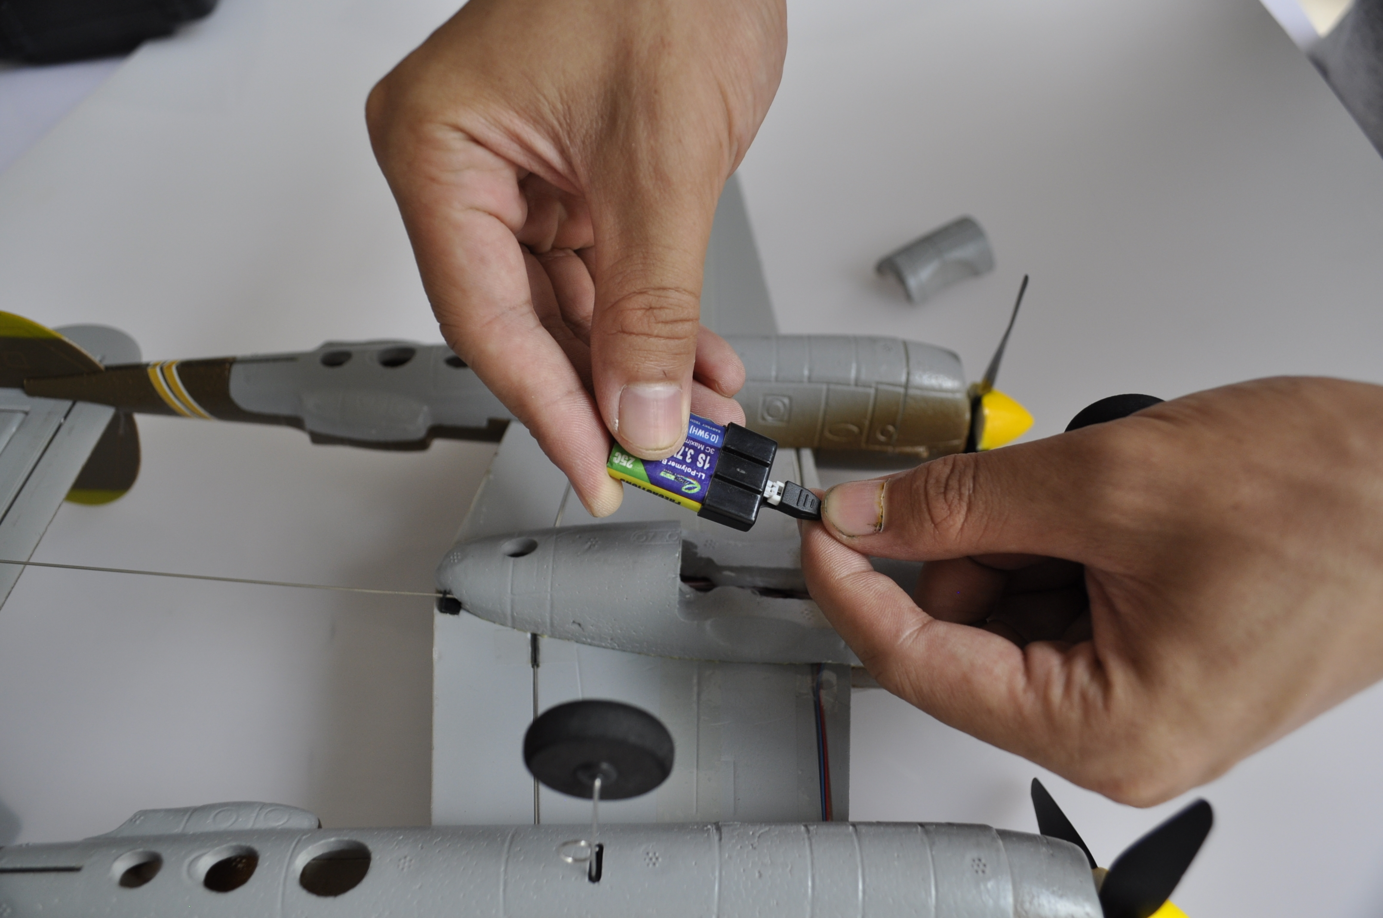
Remove nose cone or battery cover. Use two fingers to secure connector during battery installation and removal.

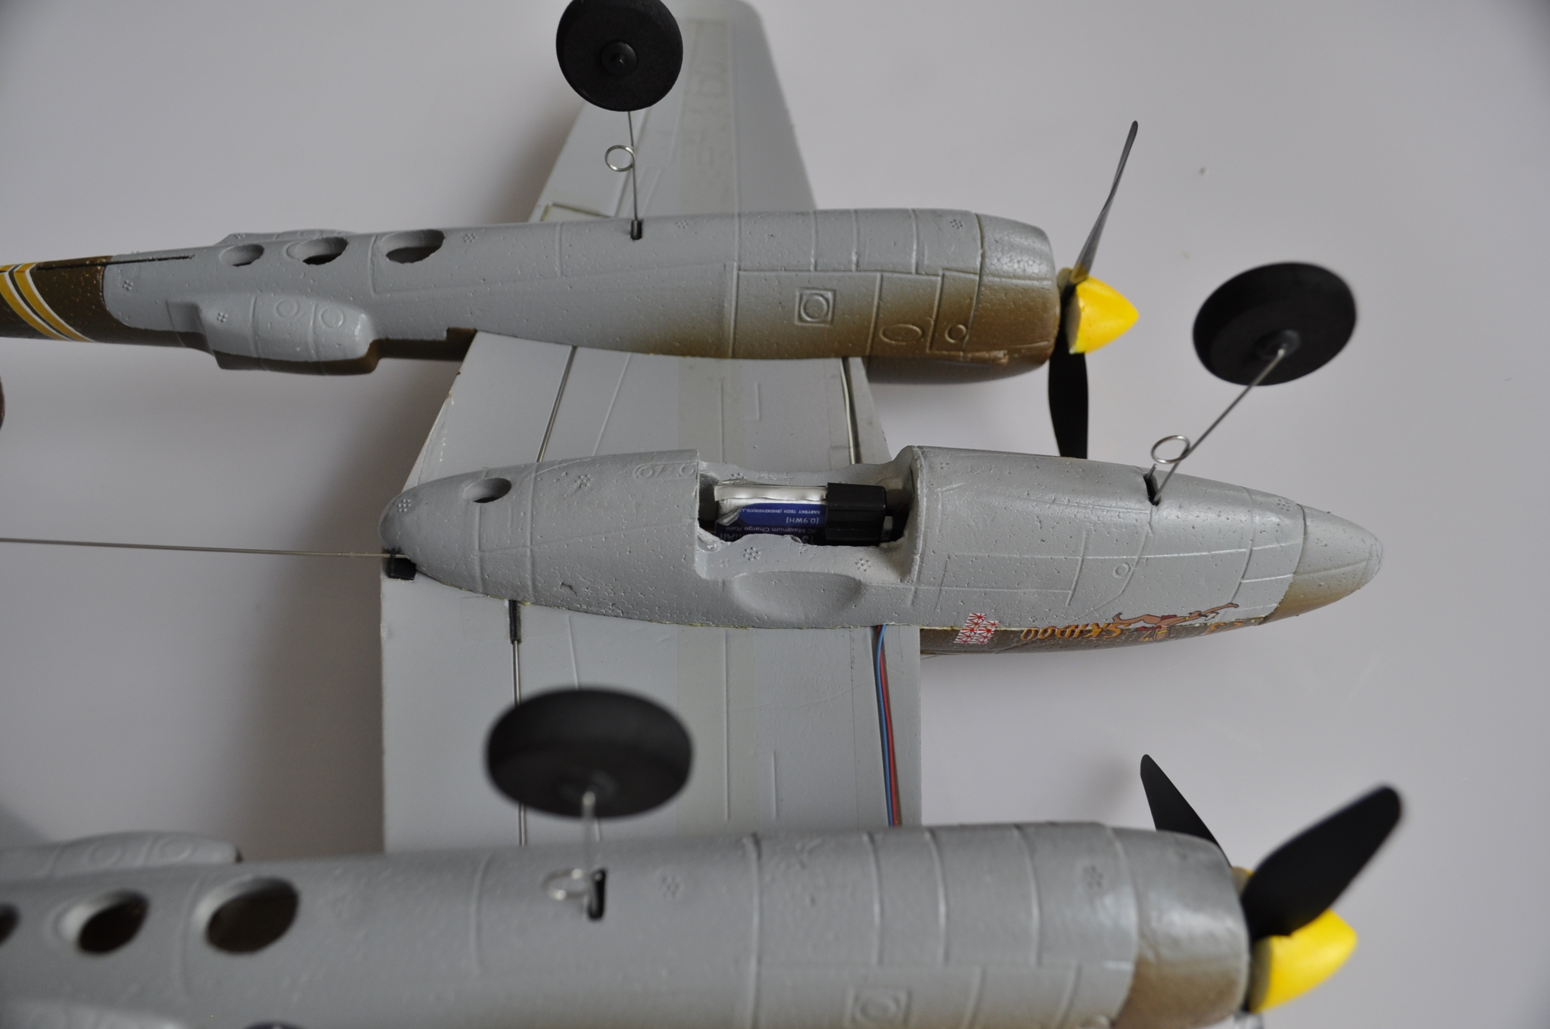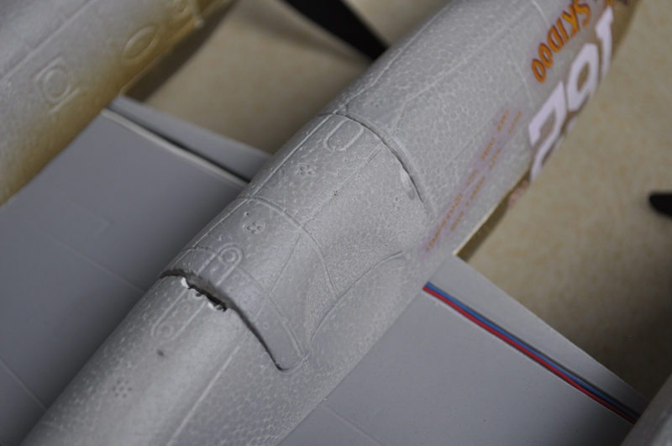
Press battery into place to secure. Replace nose cone or battery cover.

Disconnect and remove the battery after each flight by holding the battery lead with two fingers and removing the battery from the lead with the other hand. Do not yank or jerk the battery from the aircraft. This could dislodge the RX board from the Micro P-38.

CHECK THE CG

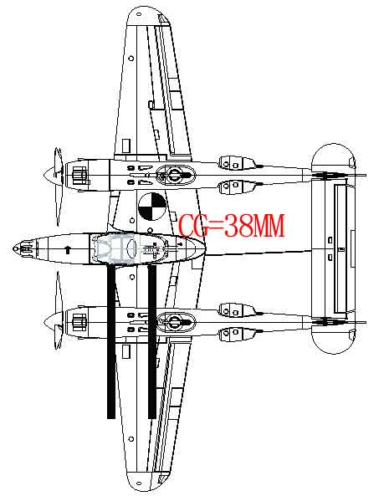

CHECK THE CONTROL SURFACE DIRECTION

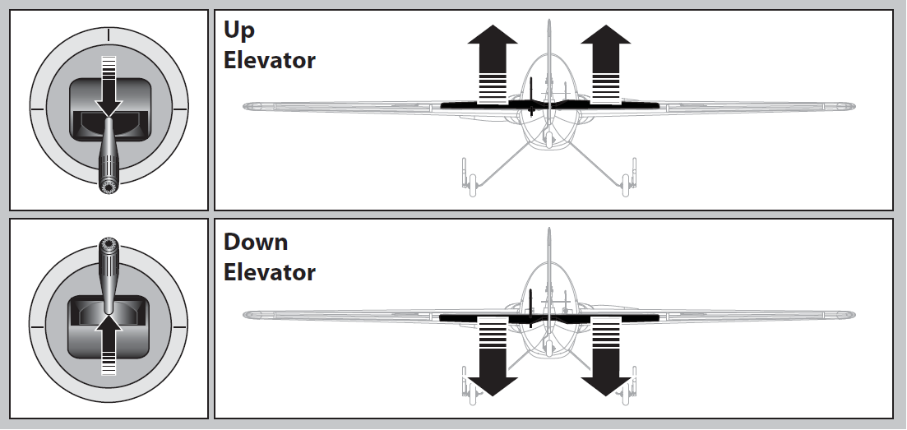

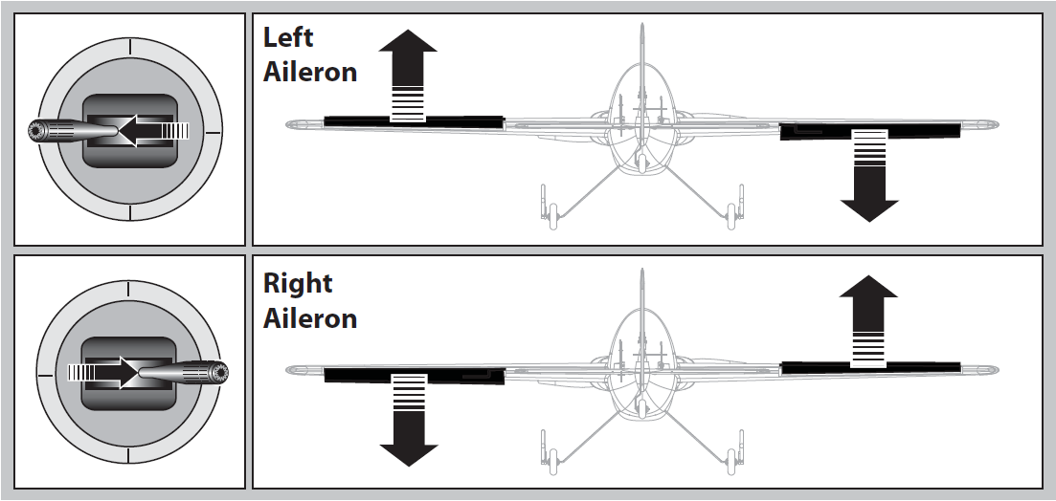

CHECK THE GYRO DIRECTION

Wrong gyro directions will lead to crashes. Check all 3 gyro directions before each flight:
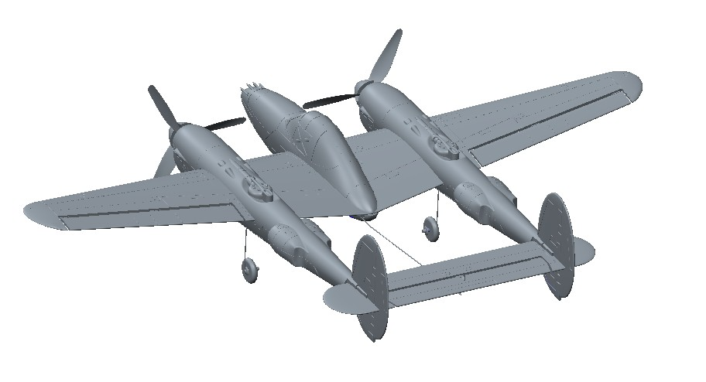
Head
Down
Head
Up
Roll
Right
Roll
Left
Turn
Right
Turn
Left

ADJUSTMENT OF LINKAGE

To alter the center position, or increase/decrease the control throw, follow these steps. Be sure to unplug the battery from the model before attempting to mechanically adjust the linkage.

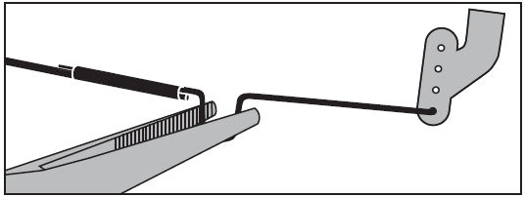

RANGE CHECK

With the transmitter powered and the battery plugged into the Micro P-38, walk 50' [15m] from the aircraft and check the control functions for proper and smooth operation.

FLYING THE MICRO

If at anytime during operation, the controls or propellers become jammed or unresponsive, reduce the power to the propellers and land. Fix the problem before attempting to fly.

Take off (or hand launch) heading directly into the wind.

NOTE: If you hand launch, you can remove the landing gear by gently pulling the landing gear wires straight out of the mounts. It is highly recommended to cut power to the motors completely just before the propellers touch the ground to prevent any damage.

Hand launch with throttle set at ¾ to full power, wings level and with a slight toss (it is not necessary to aggressively throw this model to hand launch it).

Once in the air, gain altitude to allow yourself sufficient reaction time to make a correction during flight. Once you’re comfortable, adjust the aileron and elevator trims one click at a time so that the Micro P-38 flies straight and level with the control sticks centered.

Concentrate on using small aileron control inputs so the model turns without banking the wings excessively. A slight amount of up elevator may be necessary to maintain altitude going into a turn and the elevator will need to be returned to neutral when coming out of a turn to avoid gaining altitude.

It’s recommended that you attempt to land before the motors lose power and don’t have enough voltage to maintain altitude. Always land directly into the wind if possible. Gradually reduce power when you are close to the landing spot and when close to the ground and about to touch down, pull the elevator stick back slightly to raise the nose of the model and slow the landing speed to “flair” for landing. Unplug the battery from the model and switch off the transmitter. Allow the motors to cool between flights.

PROPELLER REPLACEMENT

To replace the propellers, firstly make sure the battery is unplugged. Remove the spinner by gently wiggling it and breaking the glue joint that holds the spinner in place on the propeller. Gently and carefully hold the motor shaft with needle nose pliers or a hemostat to keep it from rotating and gently unscrew the propellers from the shafts. As shown in the picture, the left propeller unscrews clockwise and the right propeller unscrews counterclockwise. BE SURE you replace the propeller with the same rotating direction propeller! The spinner can be glued back on the propeller with a small amount of glue. Allow the glue to dry sufficiently before flying the model. Gently pull on the spinner to make sure it is really glued to the propeller.

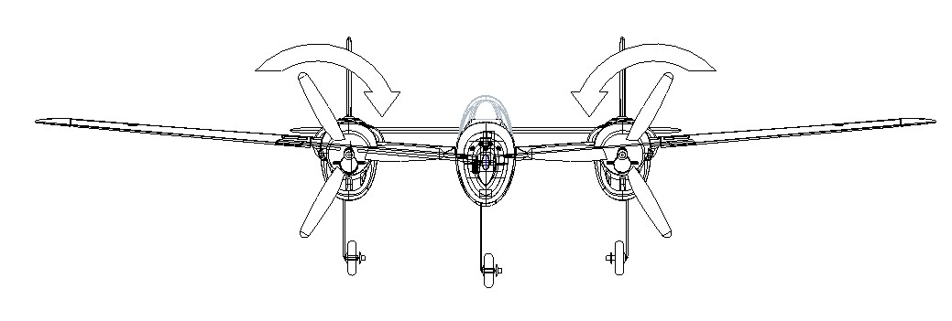
Unscrew to remove propellers

SPECIFICATIONS

Wingspan: | 525mm/20.67in
Length: | 379mm/14.92in
Wing Area: | 3.9d㎡
Wing Loading: | 18.46g/ d㎡
Flying weight: | 66g/2.33oz
Motor: | Brushed, φ8.5*20mm *2, 50000rmp
Battery: | 3.7v(1s) 250mah 25C
Servos: | 1.7g*2
Radio: | 2.4ghz 5ch

